Lab 4A – Intro to Integration Testing

Lab Intro
This lab session will give us an opportunity to write integration tests using JUnit. Last week, you were introduced to JUnit as a means of testing individual units in isolation from each other. This week, we are taking it a step further by testing the interaction between different units.
Key Term – Integration Testing
Integration testing evaluates how different parts of a software system work together. It identifies issues that may arise when individual units, previously tested separately, are combined into a complete system.

Learning Outcomes
By the end of this session, you will be able to:
- Demonstrate the ability to write integration tests that verify the interaction between distinct software modules.
- Apply principles of integration testing to ensure data consistency between a Java application and an external JSON resource.

Lab Setup
The lab setup for this lab will be slightly different from last week. I will provide the IntelliJ folder as a ZIP file with the configuration already set up.

- Download STQALab4A.zip from Moodle
- Extract the zip file to your W: drive (or D: drive if you don’t have a W: drive)
- Launch IntelliJ and open the extracted STQALab4A folder (File > Open)

After opening the project, you should see a project structure that resembles that of Figure 1. The main elements of this project structure are detailed in Table 1.

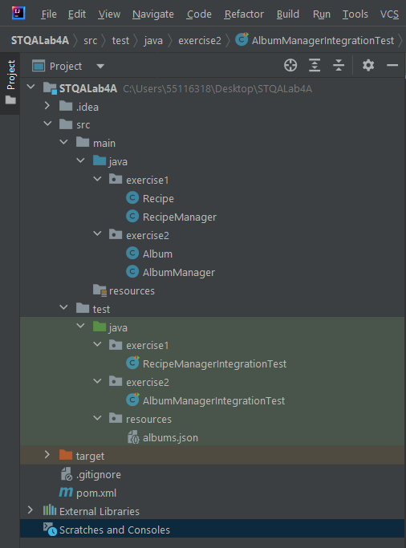
Figure 1 Project Structure of a Maven-based Project
Table 1 Main Elements of a Maven-based Project
Project Component | Description
.idea folder | This folder contains IntelliJ IDEA's project-specific configuration files and settings. It includes information about the project's structure, dependencies, and other IDE-specific settings.
src/main/java folder | This is where the main Java source code for your project resides. You place your application's Java classes and packages in this directory.
src/main/resources | Resources such as configuration files, properties files, and other non-Java files required by your application are stored in this directory.
src/test/java folder | In this directory, you write your unit and integration tests using frameworks like JUnit. It keeps your test code separate from your main application code.
src/test/java/resources folder | This package/folder contains any resources required for testing, in our case it contains a JSON file we will be using a little later.
.gitignore | This file specifies which files and directories should be ignored by Git, a version control system. It's essential for managing version control and excluding files that shouldn't be tracked. (We won’t be using version control in this lab).
pom.xml | This is a critical file in Maven projects. It's the Project Object Model (POM) file that defines your project's configuration, dependencies, plugins, and other build-related settings. Maven uses this file to manage the project's build lifecycle.

Exercise 1 – Recipe & RecipeManager Integration Testing
Our first exercise of this lab will be checking the integration between two classes: Recipe and RecipeManager.

Recipe.java – This class represents a simple Recipe data type and contains three String attributes: name, ingredients, and instructions.

RecipeManager.java – This class contains an ArrayList of Recipe objects and contains methods to add a recipe, get a recipe, and get all recipes currently in the list.
The getRecipe method accepts a String corresponding to the name of a recipe. Some rules/expected logic is provided below:
- If the user searches for a recipe that doesn’t exist, the method should return null (similar to the example we saw in the lecture).
- If the user searches for a recipe which is in the recipe manager list twice (i.e. a duplicated recipe name), then it should return the first recipe matching that name (as it does a simple linear search of the list)

Task: Navigate to the RecipeManagerIntegrationTest class in the Project’s src/test/java/exercise1 folder and follow the comments within the code to complete the exercises below. These exercises are clearly marked in the RecipeManagerIntegrationTest class.
If you are not sure if your tests should be passing or failing, Appendix A contains a list of known bugs with the program logic – but try to write the tests before you take a peek!

Table 2 Exercise 1 Tasks Summary and Hints
Exercise | Test Method Name | Hints
1.1 | testAddAndGetRecipe_ShouldReturnAddedRecipe | The lecture slides should help here, since we’re doing something nearly identical to what we did with the product/product catalog.
1.2 | testRetrievalOfNonExistentRecipe_ShouldReturnNull | You don’t need to add anything in this case, since we just want to check if we get null if a person attempts to get a recipe that doesn’t exist (so you’ll need an assertNull statement somewhere).
1.3 | testRecipesWithDuplicateNamesShouldRetrieveFirstAdded | This should involve adding some recipes with the same name and getting a recipe and asserting the recipe object retrieved is equal to the first recipe object you added.

Exercise 2 – Album & AlbumManager Integration Testing (w/ JSON file)
This exercise will involve an external JSON file which is already contained in the Project’s test resources folder. The external JSON file is named albums.json and contains JSON objects for popular albums – feel free to open the JSON file to get an idea of its structure/properties.

There are two classes, similar to the previous exercise:
Album.java – This class represents an Album data type and contains four attributes: a String for the album name, a String for the artist’s name, an int representing the year the album was released, and a String representing the genre of the album.

AlbumManager.java – This class is responsible for loading all of the albums from the albums.json file (method name: loadAlbumsFromJSON) and simply stores them in an ArrayList. A method to fetch an album is also included in the class (method name: getAlbum). Some rules/expected logic is provided below:
- If the user searches for an album, it should perform a case-insensitive search (e.g. if the user searches for “abbey road”, it should still correctly return the album with the title “Abbey Road”.
- If the user searches for an album that doesn’t exist, it should return a null reference.
- If the loadAlbumsFromJSON method is called multiple times, it should not continuously add to the ArrayList, but should instead result in the ArrayList being re-populated with the Album objects (e.g. if there are 5 albums in the JSON file, then calling loadAlbumsFromJSON 3 times should still result in there being 5 albums – not 15).

Table 3 contains some test method names that are already populated in the AlbumManagerIntegrationTest test class. It is your job to complete their implementation by reading the test method name. You will notice that Exercises 2.2-2.5 do not have hints and Appendix A does not contain a list of known bugs, so you may find these slightly more challenging to implement.

Table 3 Exercise 2 Tasks Summary and Hints
Exercise | Test Method Name | Hints
2.1 | testRetrievalOfNonExistentAlbumShouldReturnNull | Very similar to the testing for a non-existent recipe from exercise 1.
2.2 | testGetAlbumIsCaseInsensitiveShouldReturnCorrectAlbum
2.3 | testConstructorShouldLoadAlbums
2.4 | testConstructorWithInvalidFilePathShouldThrowRuntimeException
2.5 | testLoadAlbumsFromJSONShouldClearPreviousAlbums

Can you think of any more unit tests that could be performed to test the integration between our code and the JSON file? If you take a look at the AlbumManager class, it contains methods to addAlbum and saveAlbumsToJSON – and none of our tests so far have even touched these methods. Implement some more integration unit tests to test that the functionality is as we would expect. If you’re feeling adventurous you can attempt to fix any issues you have identified as a result of your tests failing…

Lab Summary
This lab has introduced the concept of integration testing by using the JUnit testing framework. We have had the opportunity to not only test the interaction between classes, but also test the interaction between external sources.
Important: At this point you should have completed, or be close to completing, your first assessment: the test plan. If you have finished this lab sheet and have any questions relating to the test plan, the labs this week will be your last guaranteed opportunity to get these questions answered before Friday’s deadline.

Appendix A – Known Bugs
Try not to look at these known bugs straight away, since in the real world we do not have the luxury of having a document outlining all of the undiscovered bugs in a system (unless the developers themselves have documented the bugs they are currently aware of at the time of passing the code to the testing team).

Exercise 1 – Recipe & RecipeManager
Exercise | Test Method Name | Hints
1.1 | testAddAndGetRecipe_ShouldReturnAddedRecipe | This test should pass, as there are no known issues associated with adding and retrieving recipes.
1.2 | testRetrievalOfNonExistentRecipe_ShouldReturnNull | This test should fail since there is indeed an issue with the getRecipe method of the RecipeManager class – If the for loop finishes without returning a recipe, it returns the last thing in the arraylist (assuming there is something there), otherwise, you’ll get an ArrayIndexOutOfBounds Exception.
1.3 | testRecipesWithDuplicateNamesShouldRetrieveFirstAdded | This test should pass, as there are no known issues associated with this logic.

Exercise 2 – Album & AlbumManager
Exercise | Test Method Name | Hints
2.1 | testRetrievalOfNonExistentAlbum_ShouldReturnNull | This test should fail since there is an issue to logic of getAlbum – instead of returning null if it doesn’t find the album name, it returns the first album in the arraylist (index 0).

